all-about-the-music - OL-US-27092018-1954142346277

<https://demo-customlinks.com/all-about-the-music/>

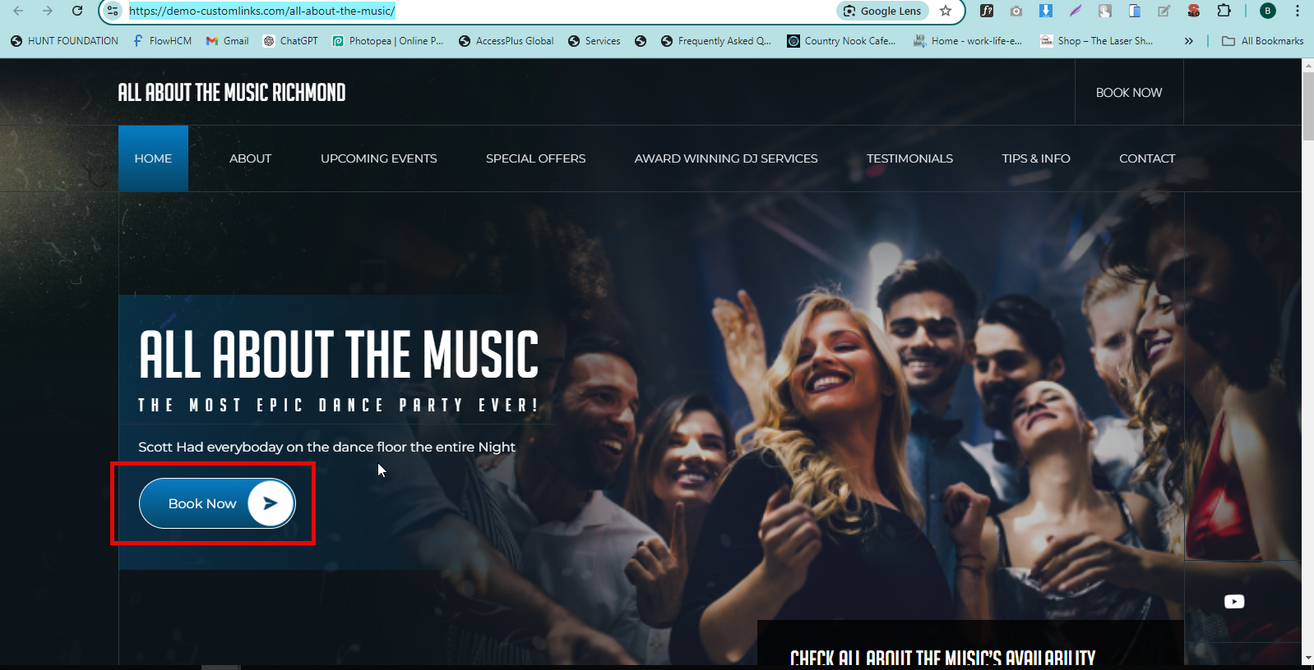

QA>>>Banner Book Now Button Text Capital Resolved

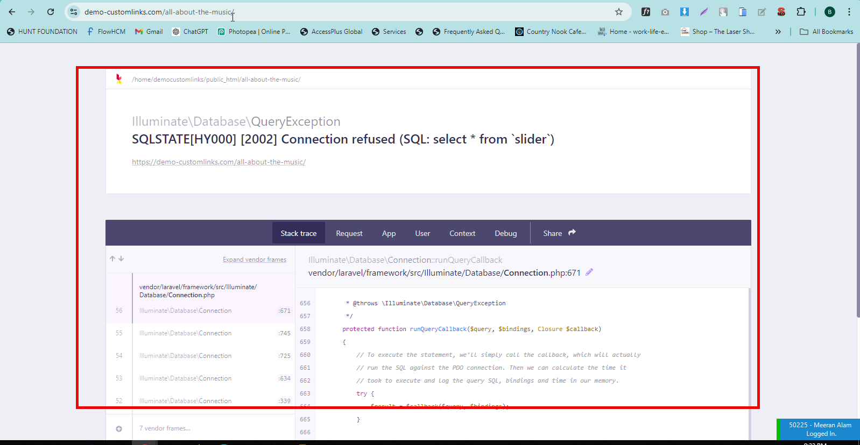

QA>>website open karta ha ye Error agaye Resolved

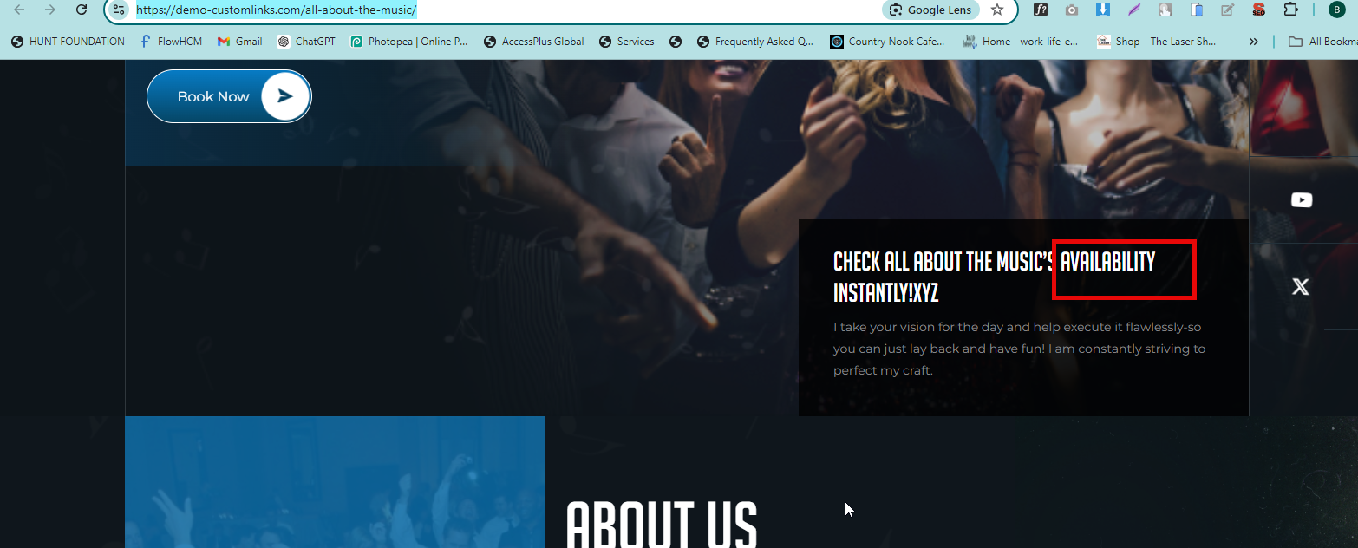

QA>>availability text Align next line

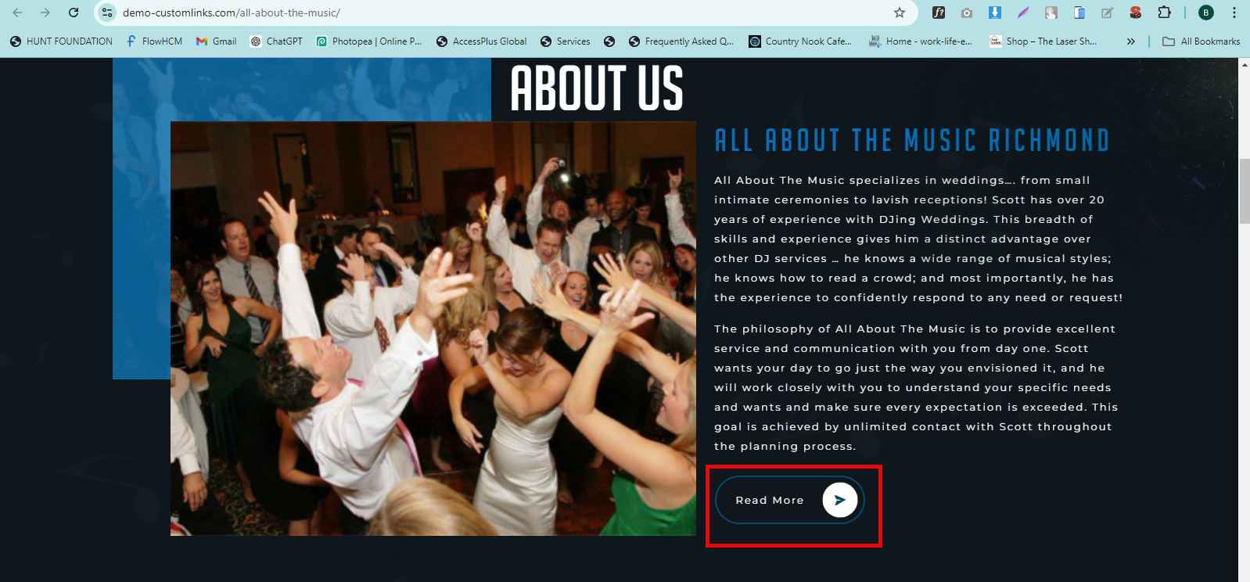

QA>Read More button text should be Capital (Fix That All Over The Site) Resolved

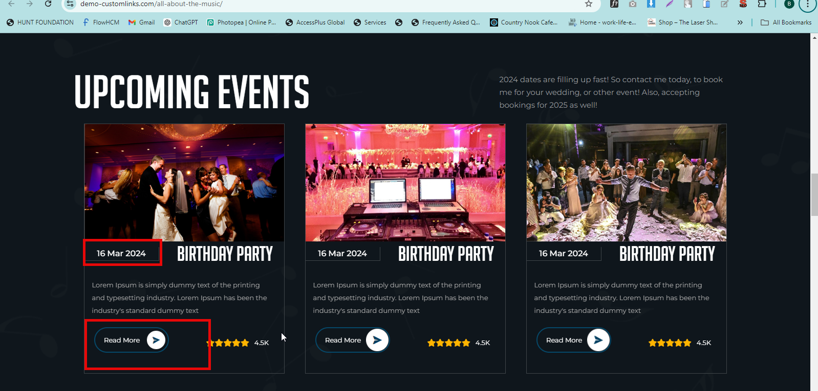

QA>>Home page Event Section date design Should be Same as per html (Fix That All Over The site) Resolved

QA>>>Button Name Should be Same as per html (More Detail) Resolved

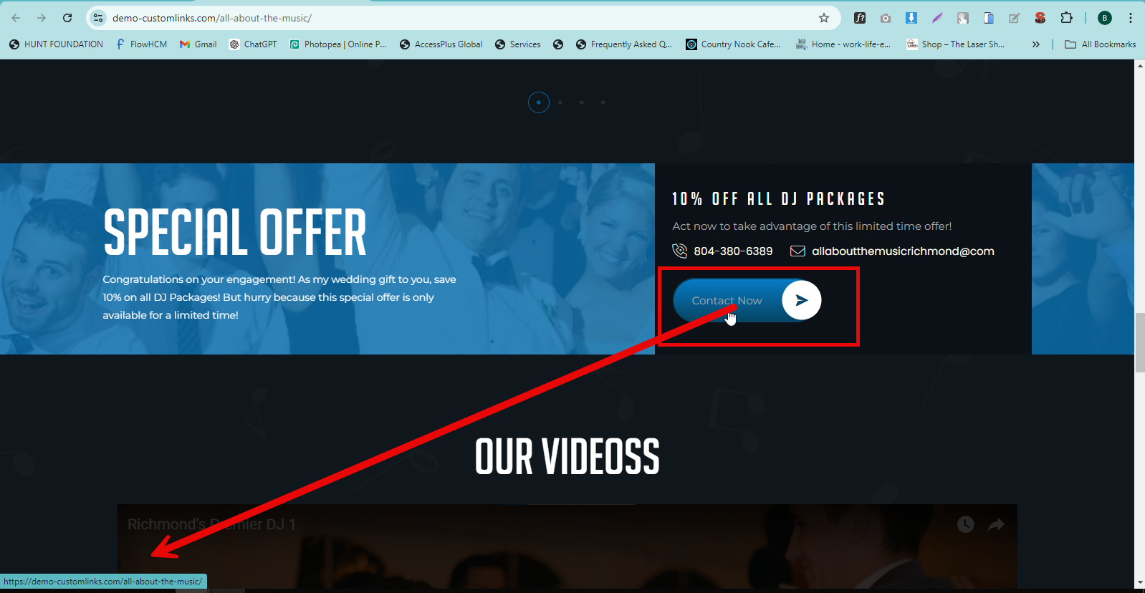

QA>>>Contact Us button link Relevant page Resolved

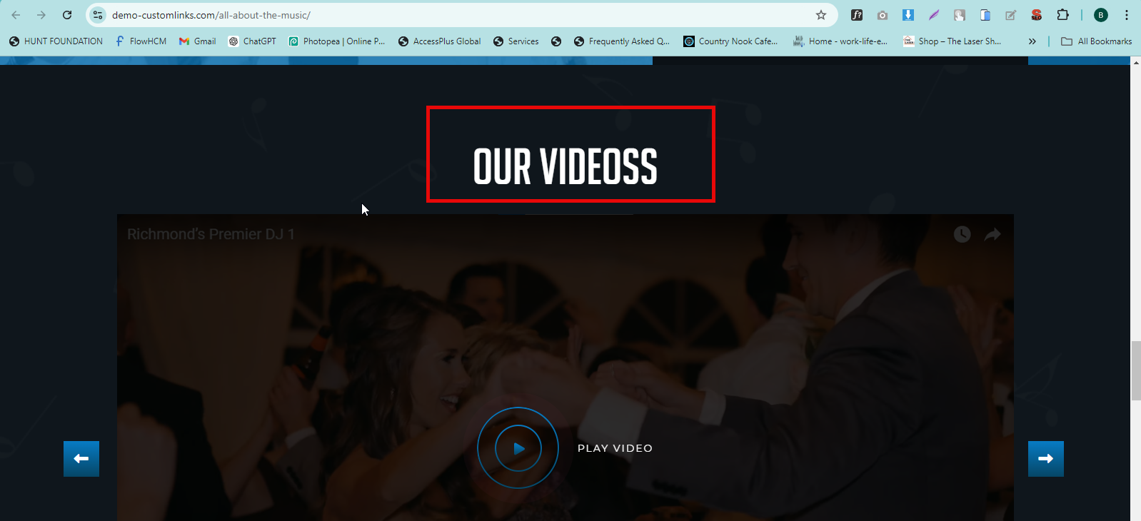

QA>>>please Check Spelling “Videos” Resolved

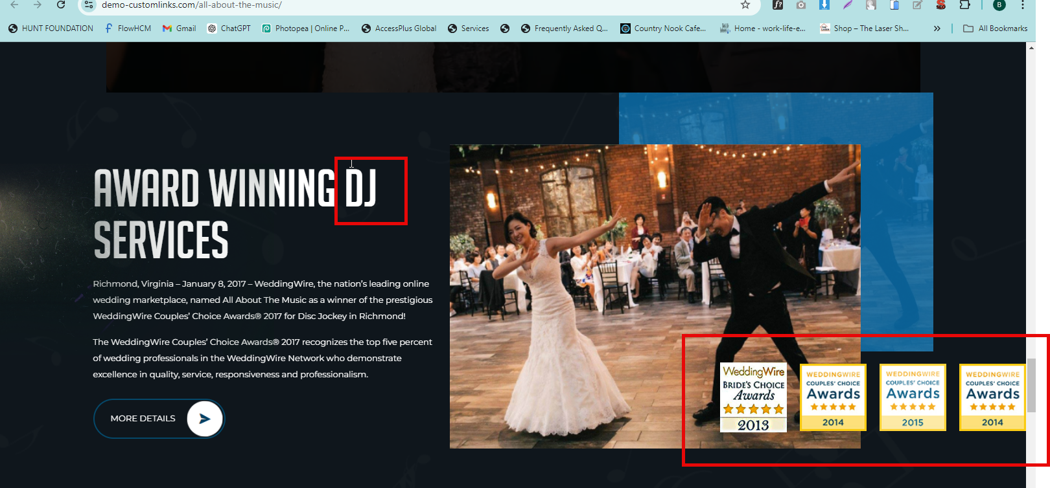

QA>>DJ text Align next line

QA>>>Award Box Layout Style Should be Same as per psd HTML ISSUE

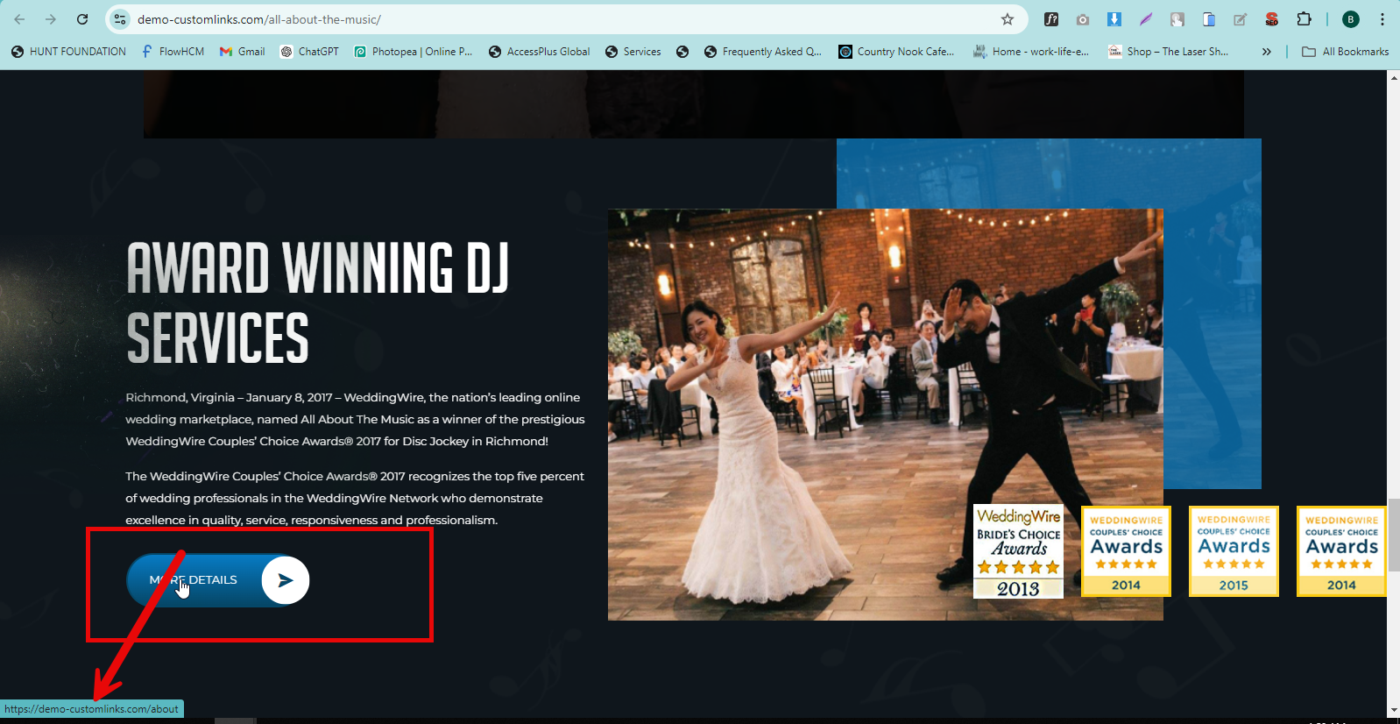

QA>>>More Detail button Link Relevant Page Resolved

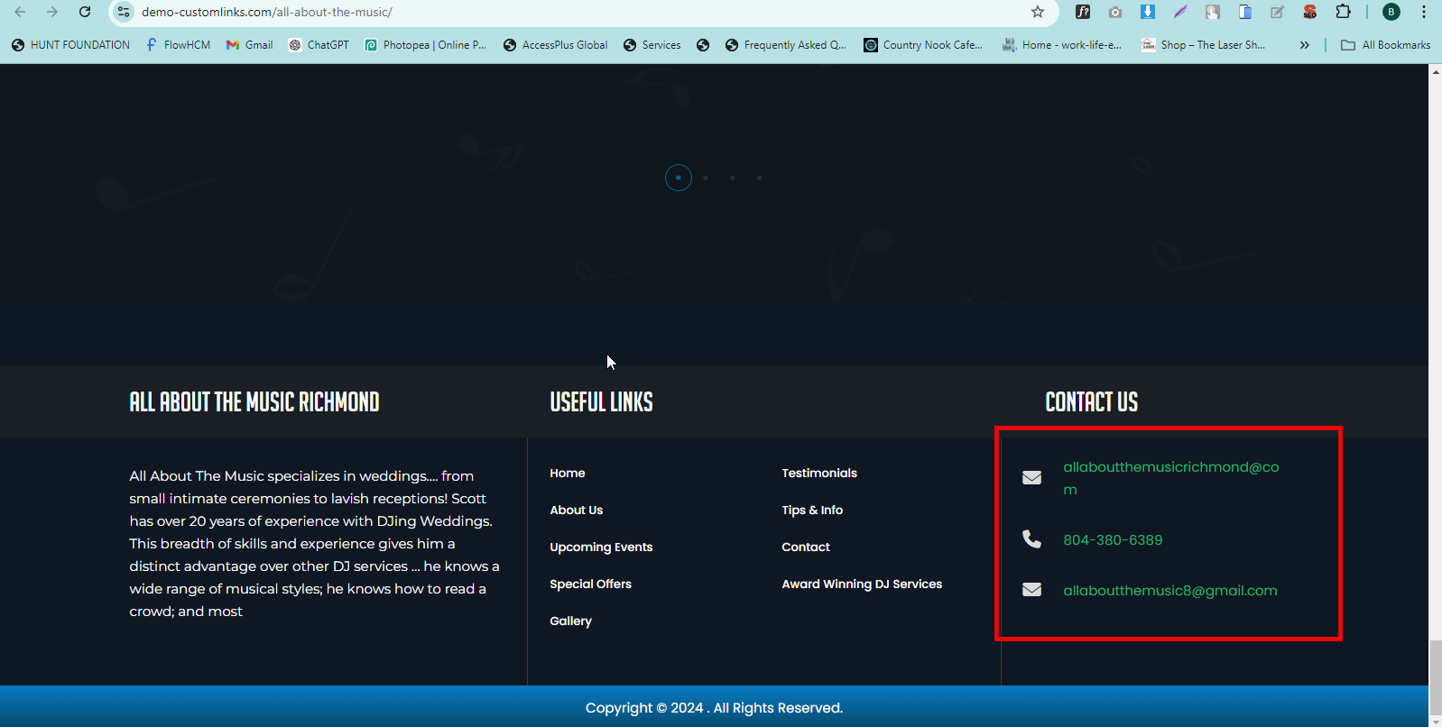

QA>>>Footer Contact us Email Align On one line HTML ISSUE

QA>>>Contact Us Text Color Should be Same as per psd HTML ISSUE

QA>>>Footer Copyright Add Website Name Resolved

<https://demo-customlinks.com/all-about-the-music/about>

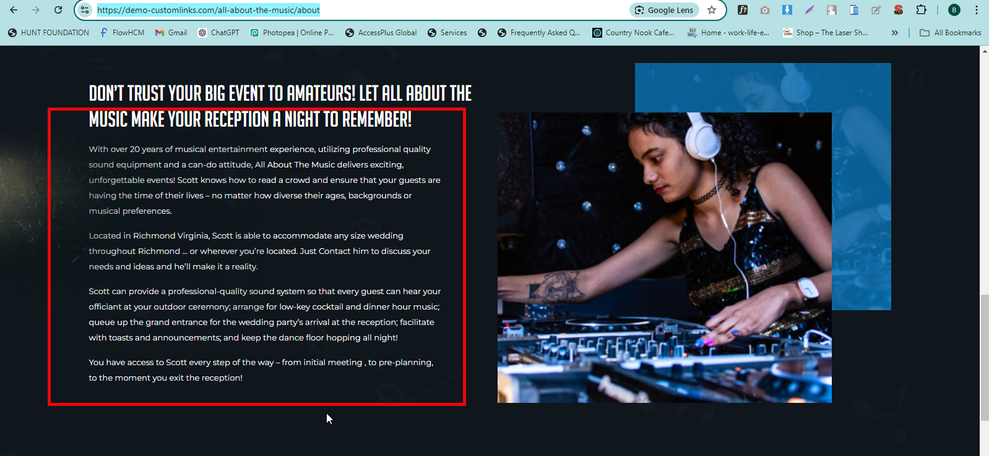

QA>>>Text Align Should be Same as Per html Resolved

<https://demo-customlinks.com/all-about-the-music/upcoming-events>

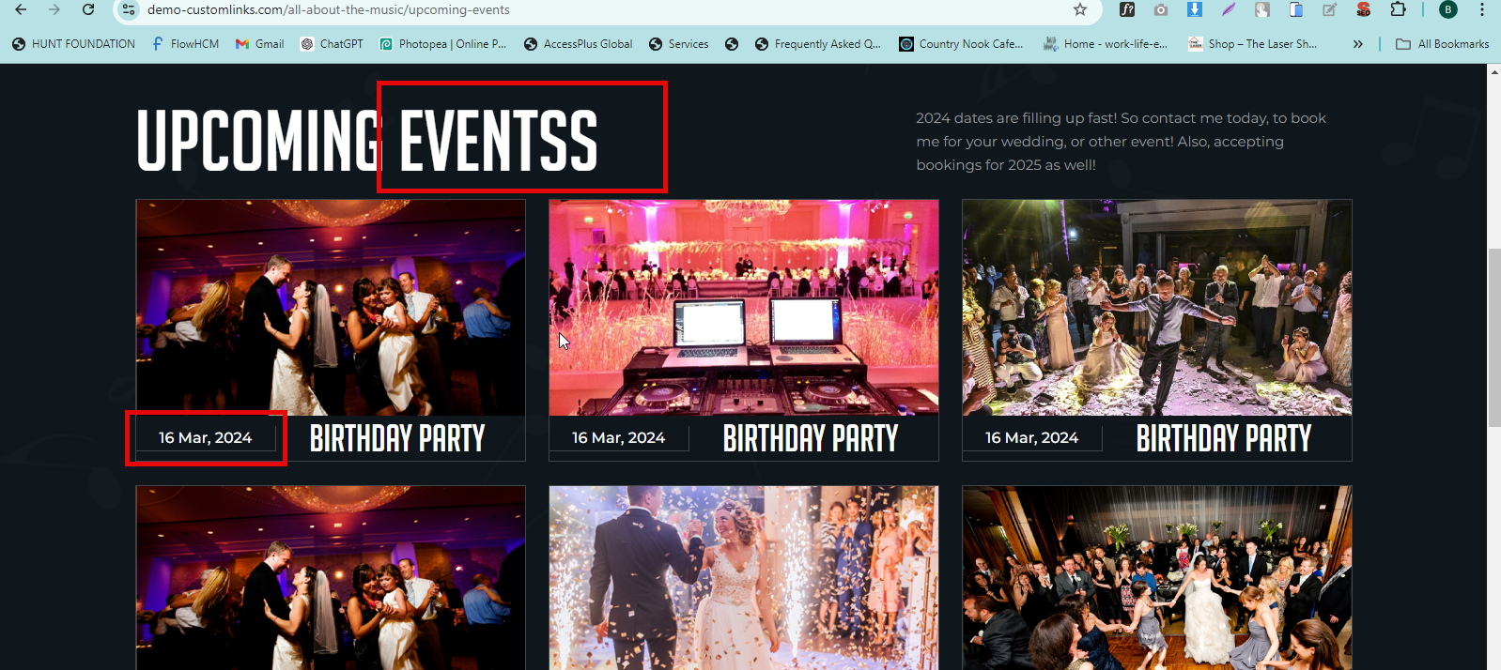

QA>>>Please Check Spelling “Events “Resolved

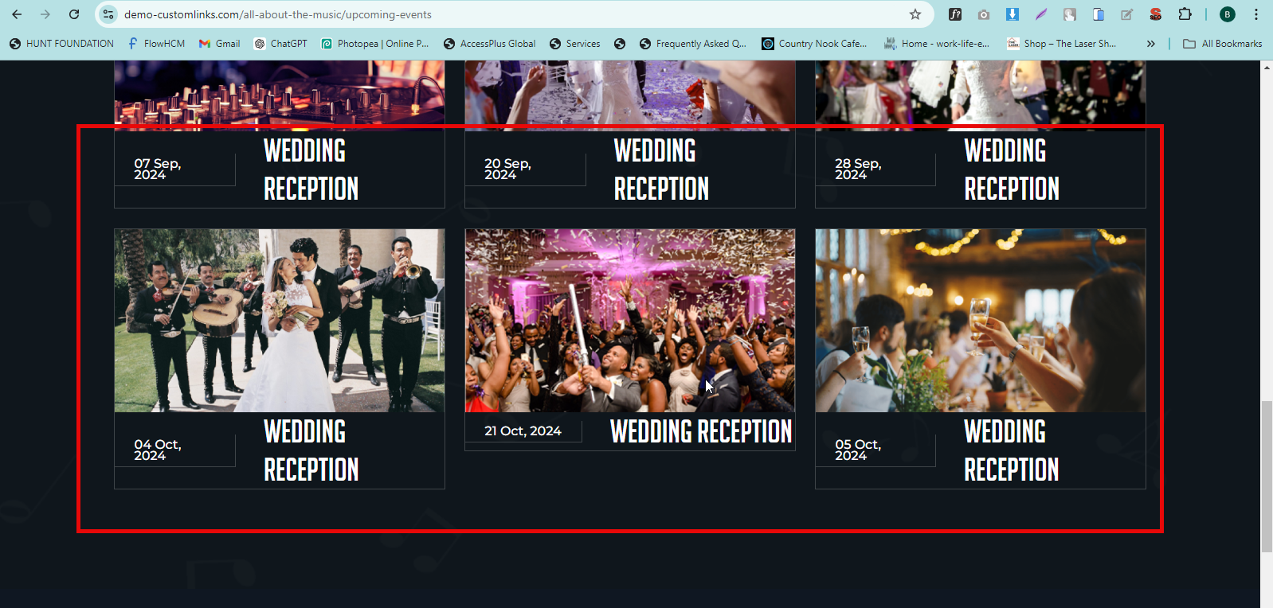

QA>>>Fix This

Resolved

<https://demo-customlinks.com/all-about-the-music/special_offer>

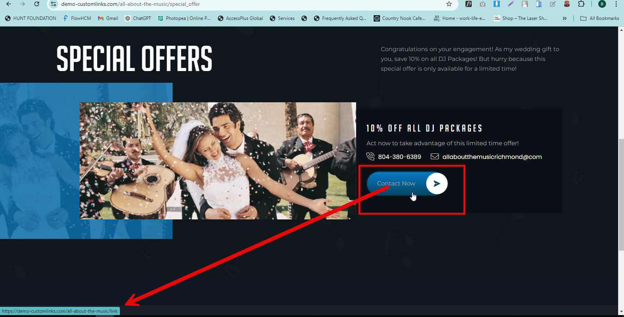

QA>>>Contact now Button link Resolved

QA>>>When we Click on Contact us button goes on 404 page Resolved

<https://demo-customlinks.com/all-about-the-music/link>

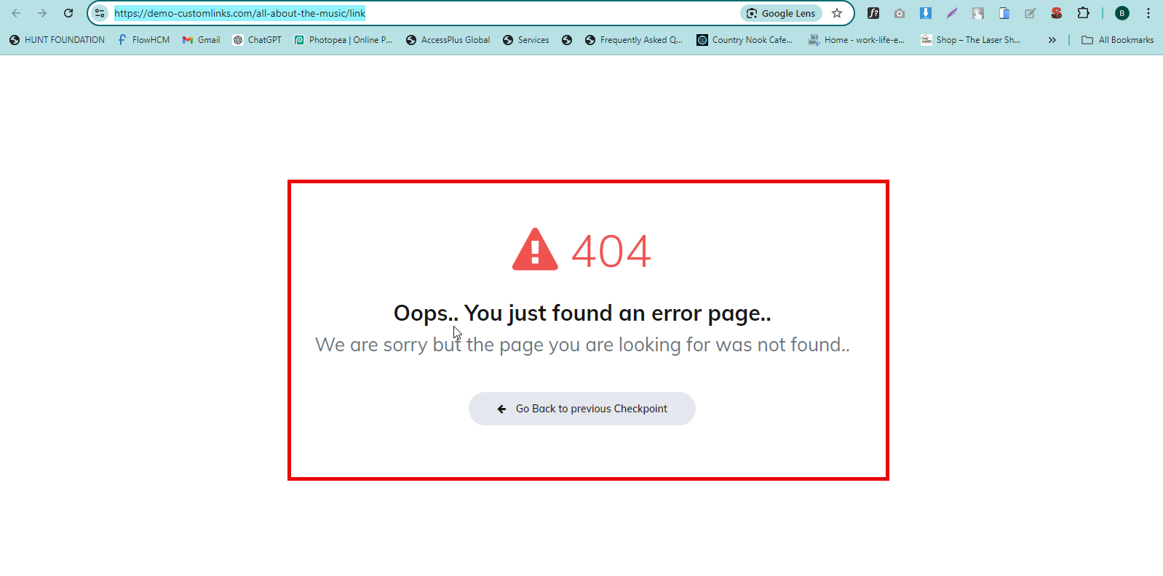

<https://demo-customlinks.com/all-about-the-music/awards> Resolved

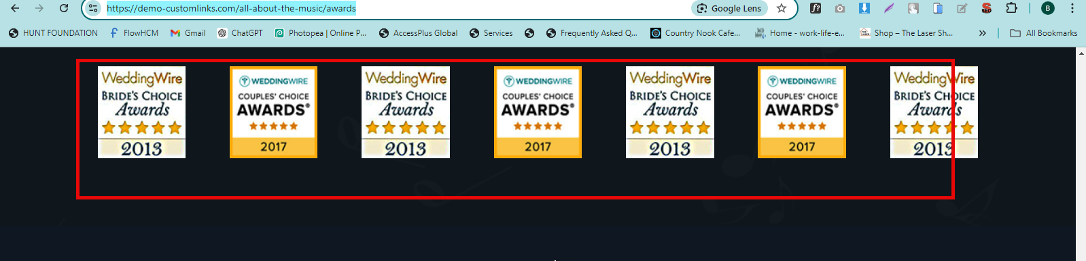

QA>>>Award image use should be Same as Per html Resolved

<https://demo-customlinks.com/all-about-the-music/contact-us>

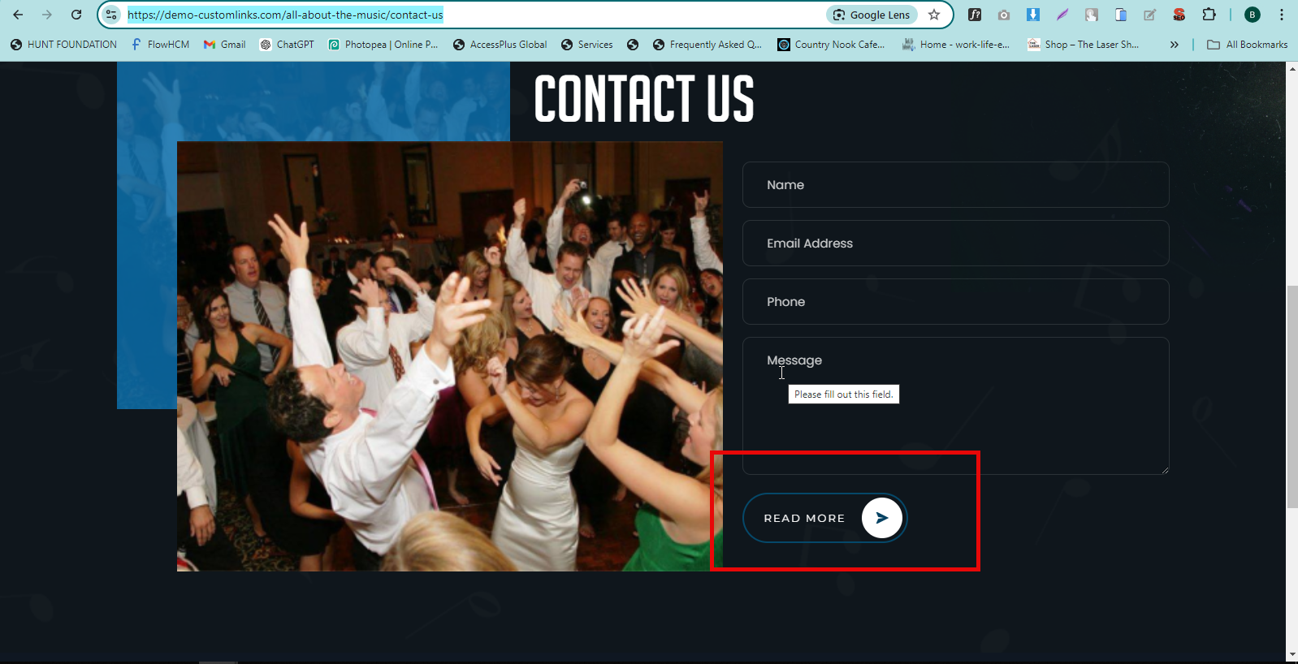

QA>>>Form k nechy read More Button Resolved

QA>>>Please Add Submit Button Resolved

<https://demo-customlinks.com/all-about-the-music/bookings>

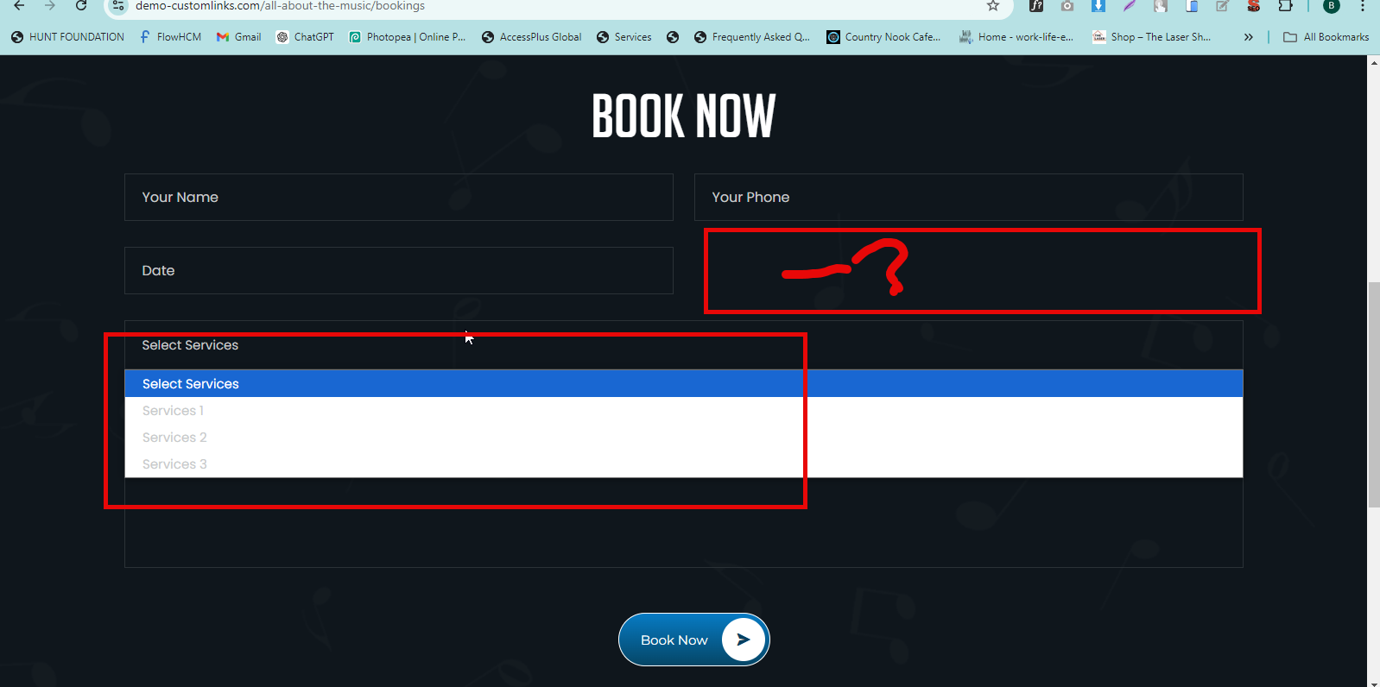

QA>>one Fields is Missing its eliminated deliberately

QA>>>service drop Down text is Not visible HTML ISSUE

DYNAMIC ISSUE BELOW:- The Client Hasn’t provided any logo that’s why its empty..

<https://demo-customlinks.com/all-about-the-music/login>

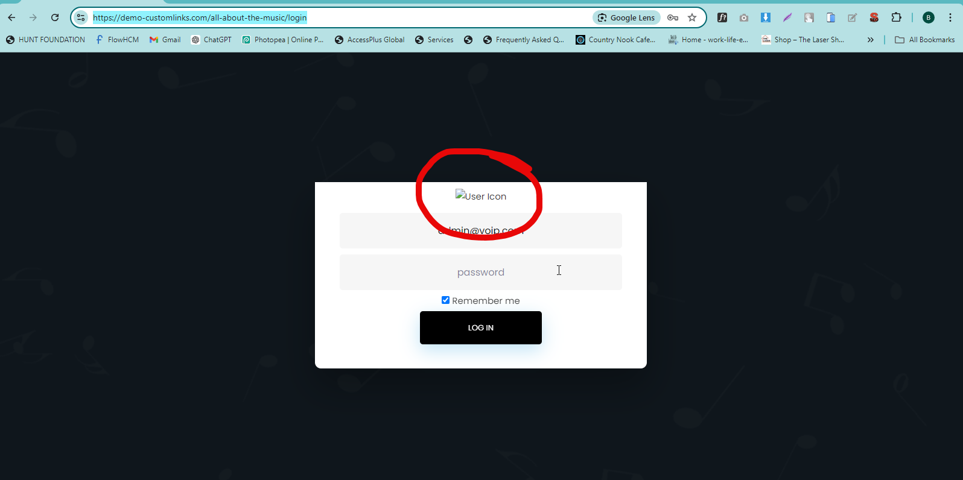

QA>> user icon is Not visible

<https://demo-customlinks.com/all-about-the-music/panel/inquiries>

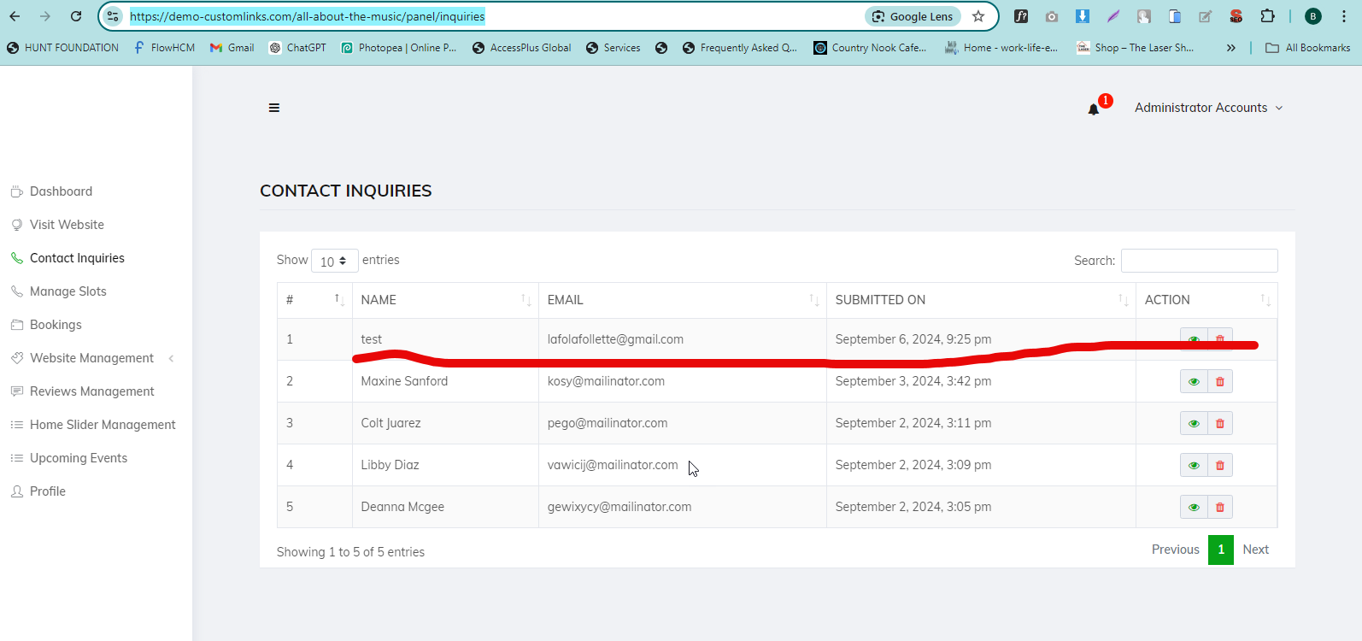

QA>>Received inquiries form detail RESOLVED

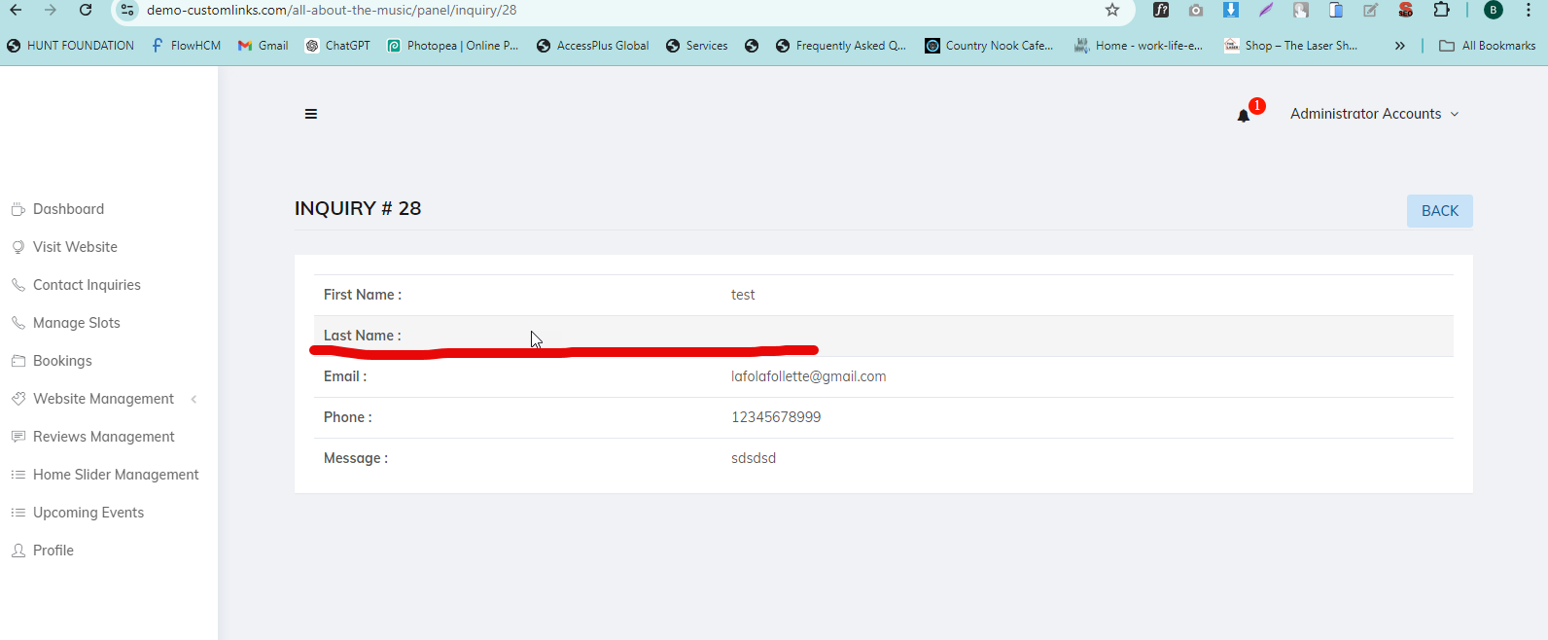

QA>>Last Name ki Field Contact Form me nahi ha RESOLVED

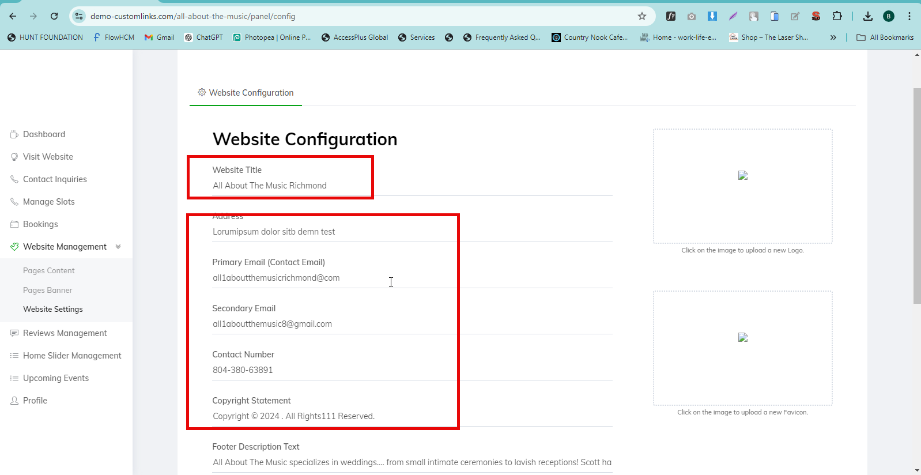

QA>>> Mark is Not dynamic RESOLVED

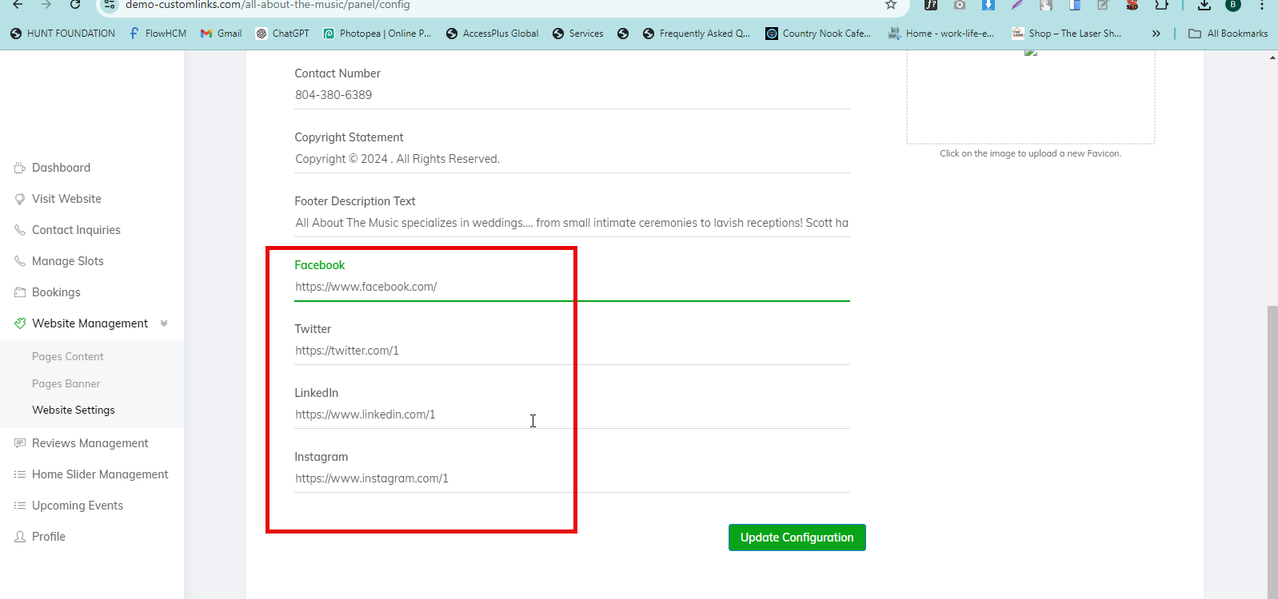

QA>>Social Media link is Not dynamic RESOLVED

<https://demo-customlinks.com/all-about-the-music/> RESOLVED

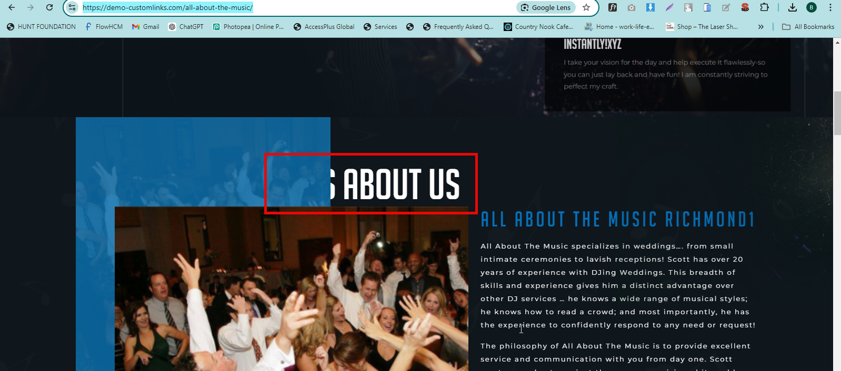

QA>>>when we text adding one more heading text overlapping on image HTML ISSUE

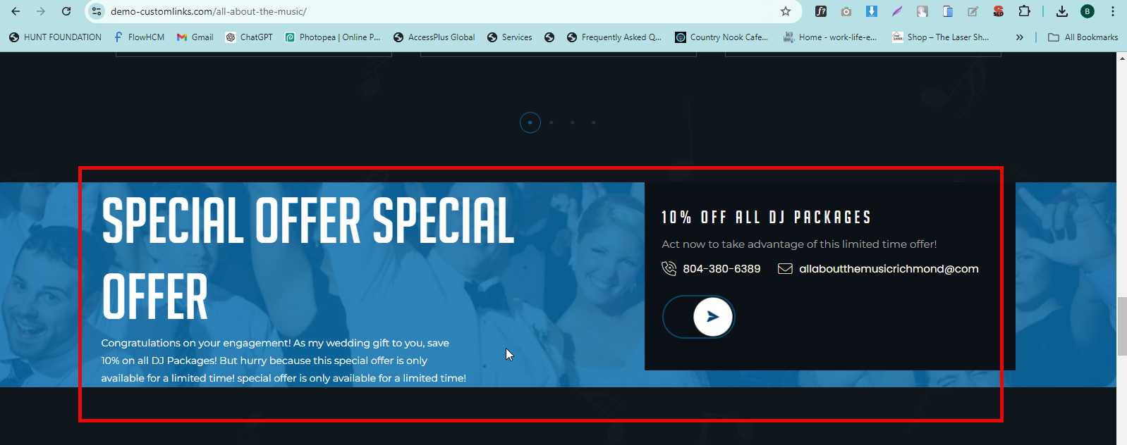

QA>>>When we adding Some text Contact us button missing HTML ISSUE

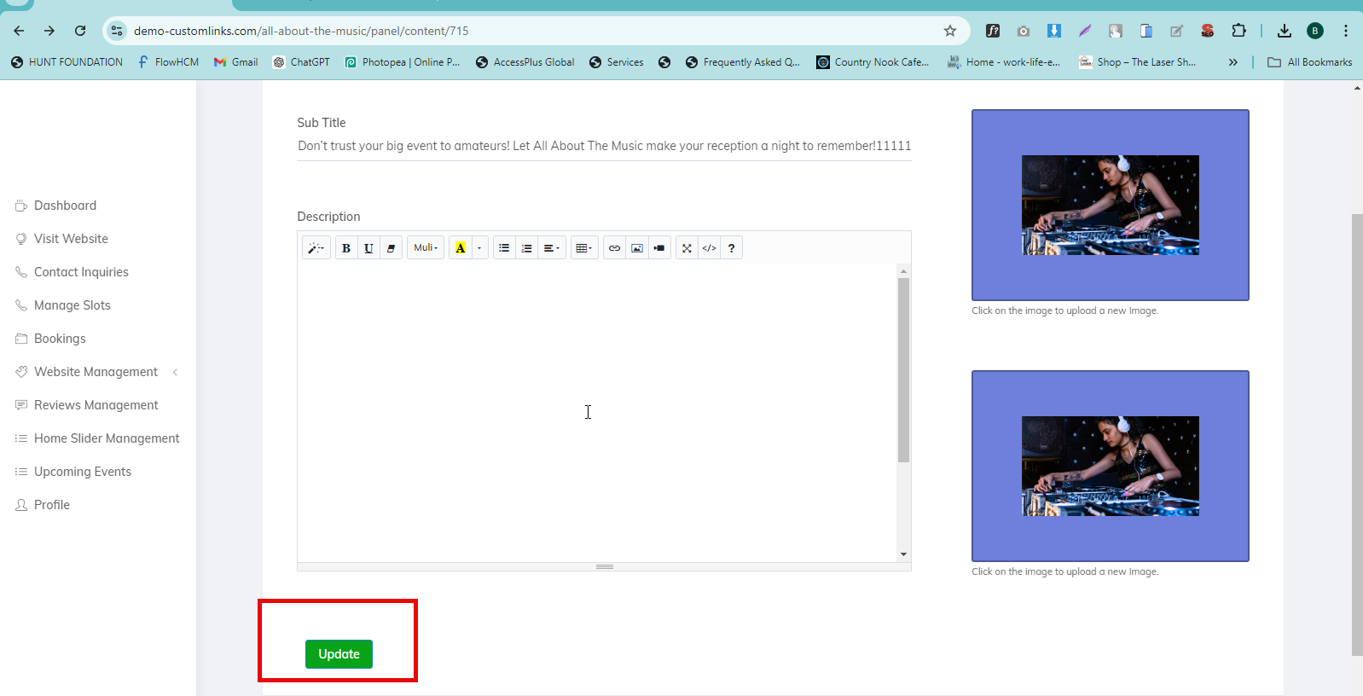

QA>>When we Click on updated Show below Error

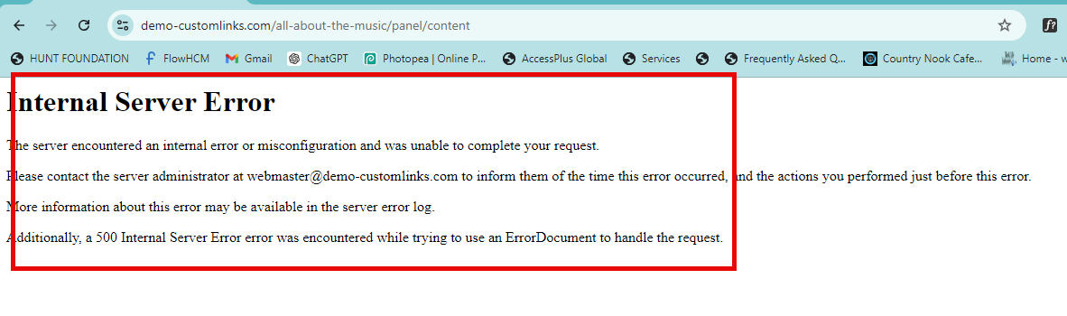 RESOLVED

<https://demo-customlinks.com/all-about-the-music/panel/content/717>

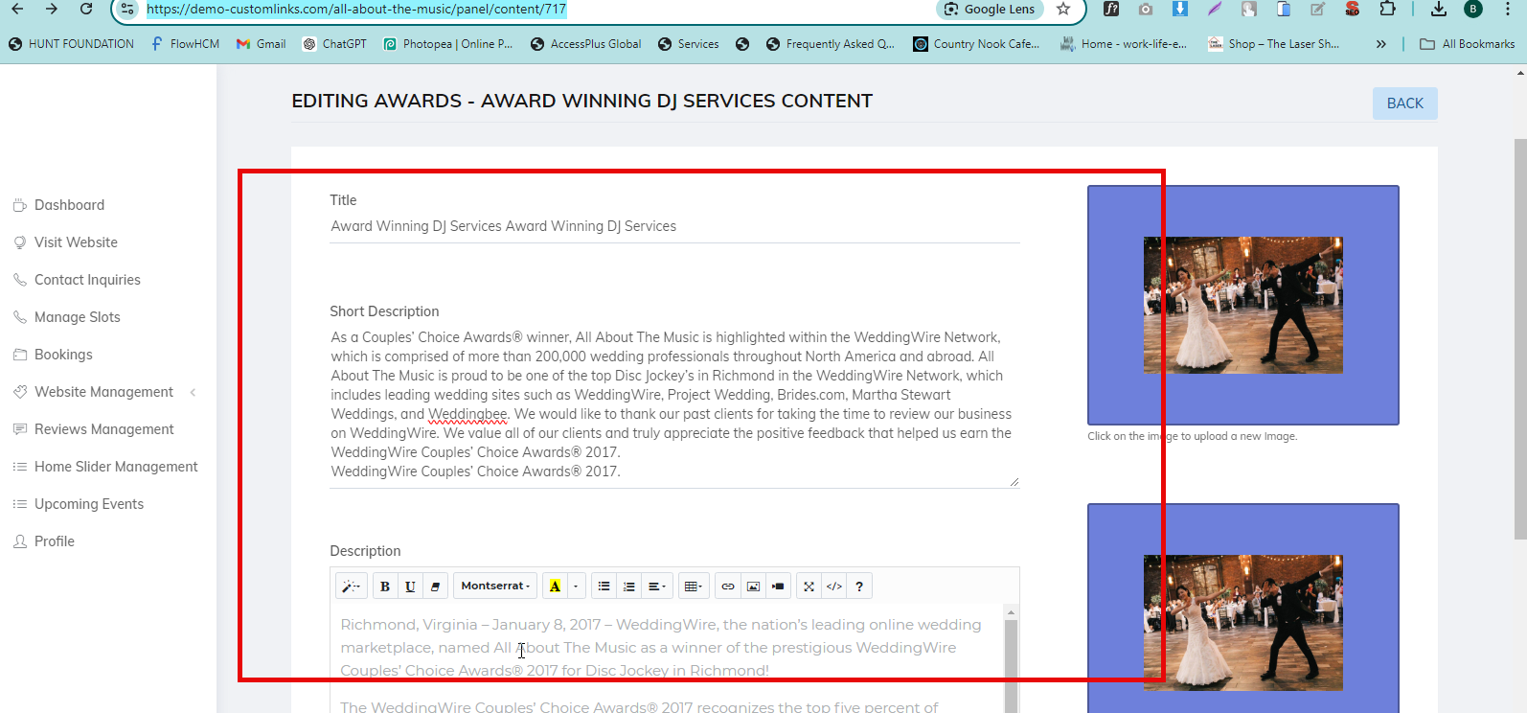 RESOLVED

QA>>>When we updated show me below Error server Error

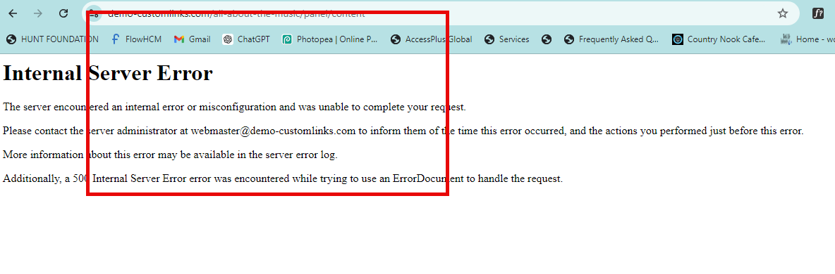 RESOLVED

<https://demo-customlinks.com/all-about-the-music/contact-us>

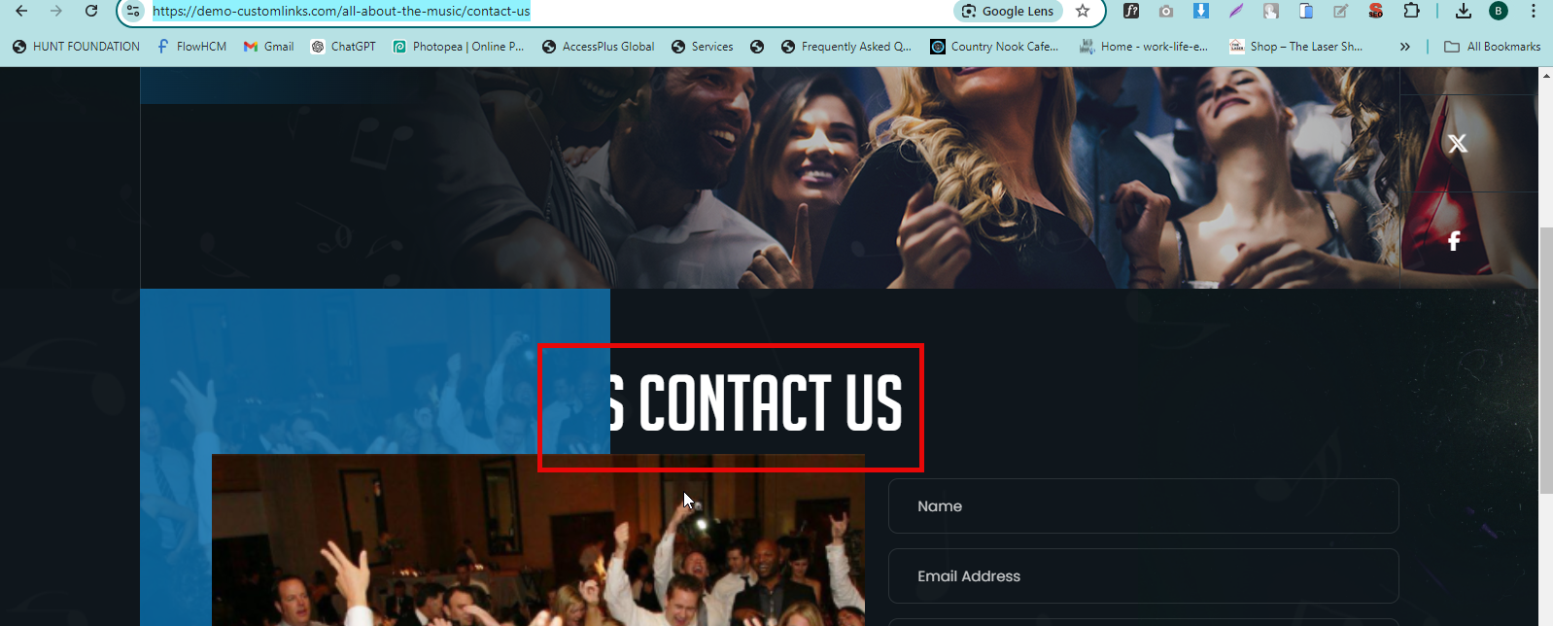

QA>>When we Adding Some heading text is overlap HTML ISSUE